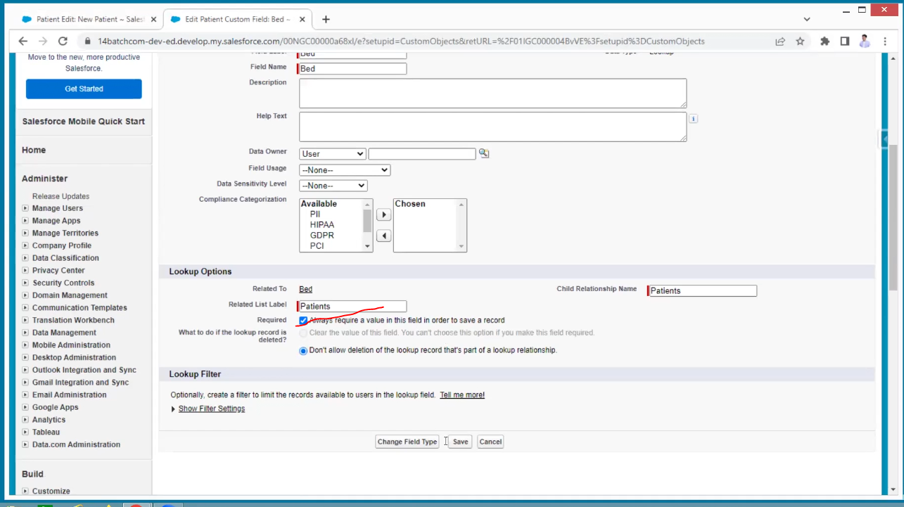

For example, in patients I am not filling the bed, and I can save it this should not happen

For Inpatient the bed is mandatory

But in the outpatient also bed is displaying

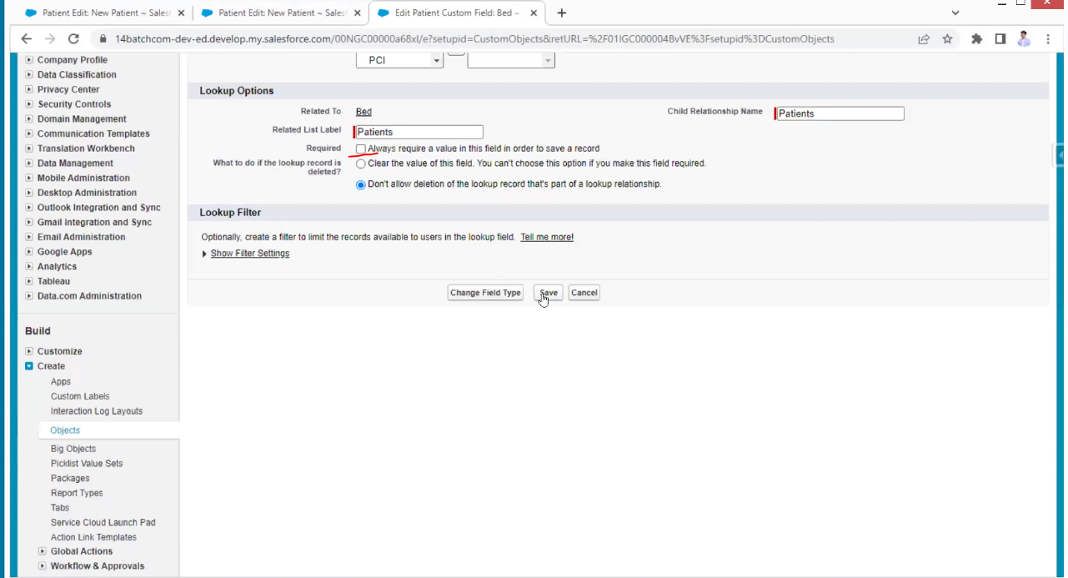

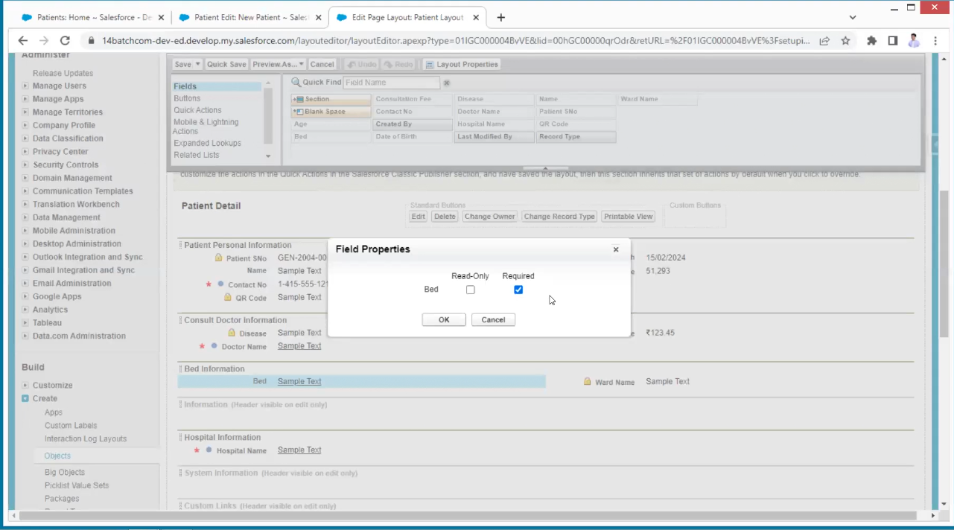

This is the page level record mandatory

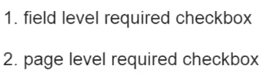

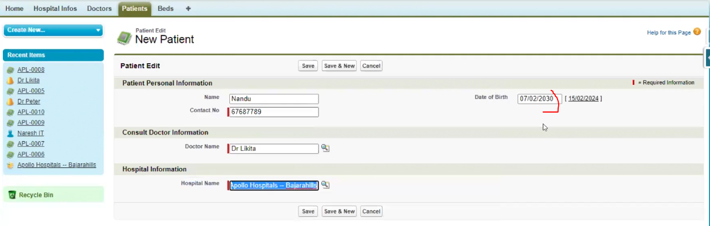

The date of birth must be today or less than today.

This is like to validate the data the concept is validation rules

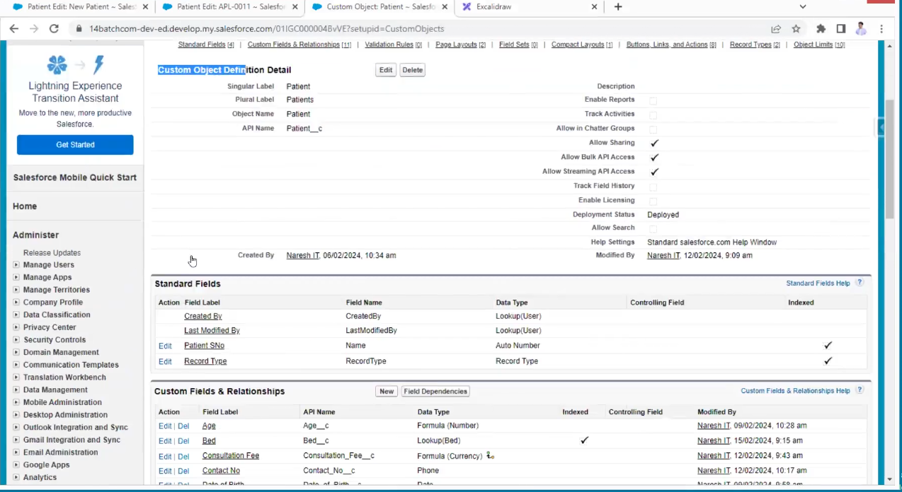

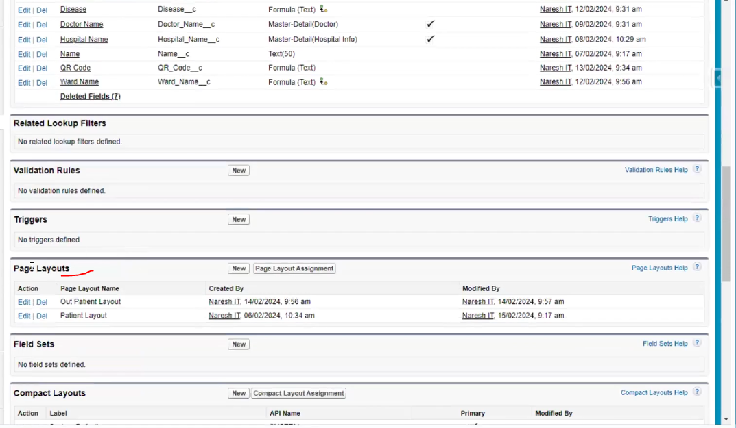

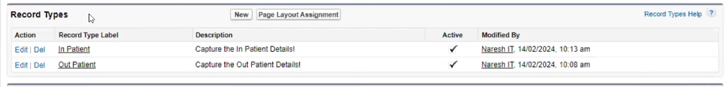

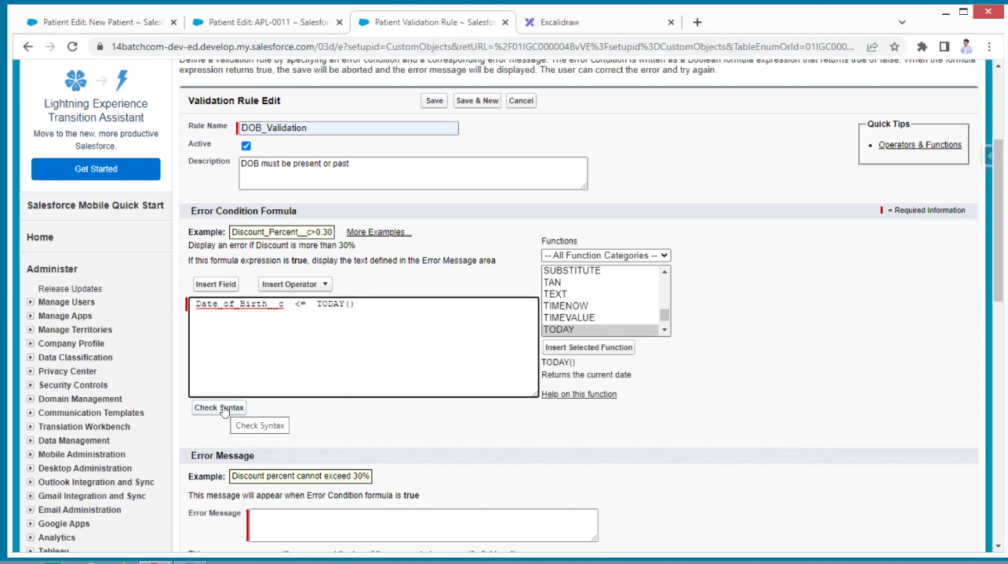

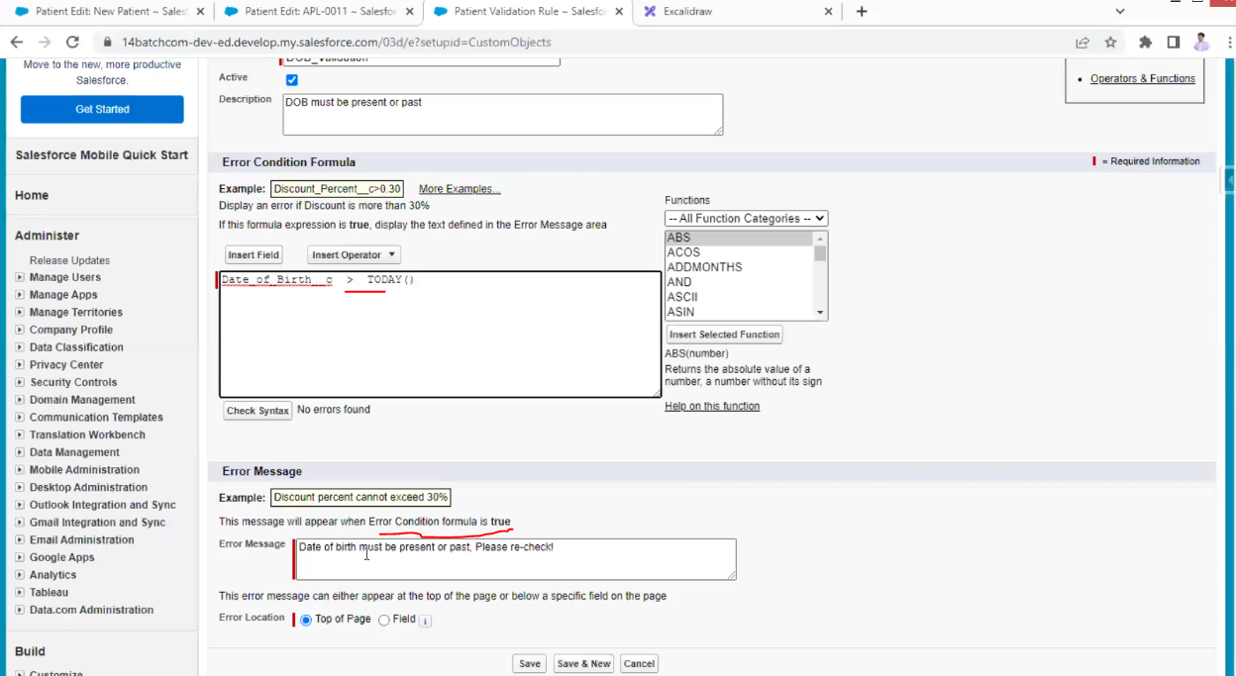

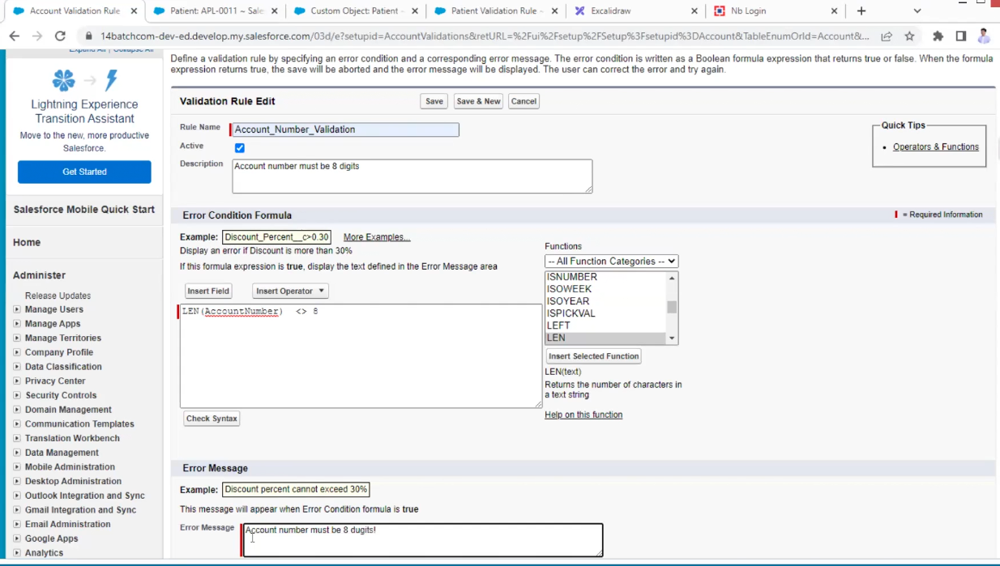

Another example from bank

Making records as mandatory

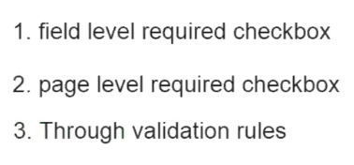

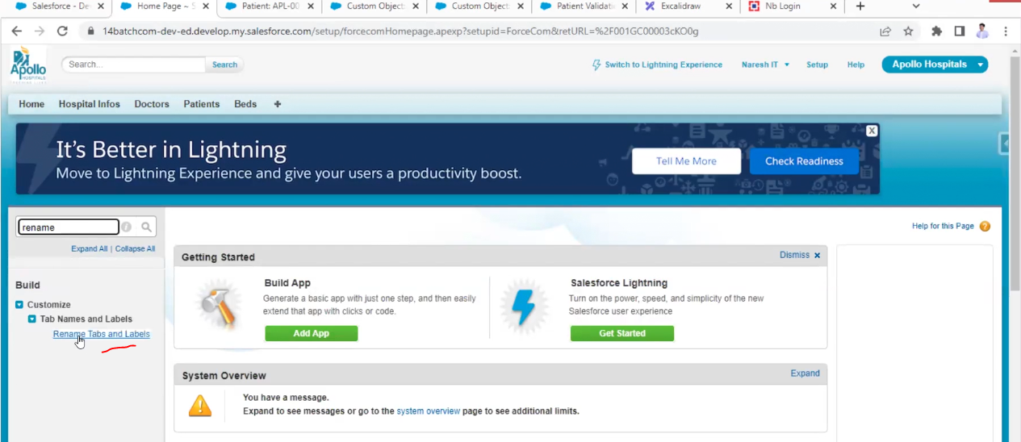

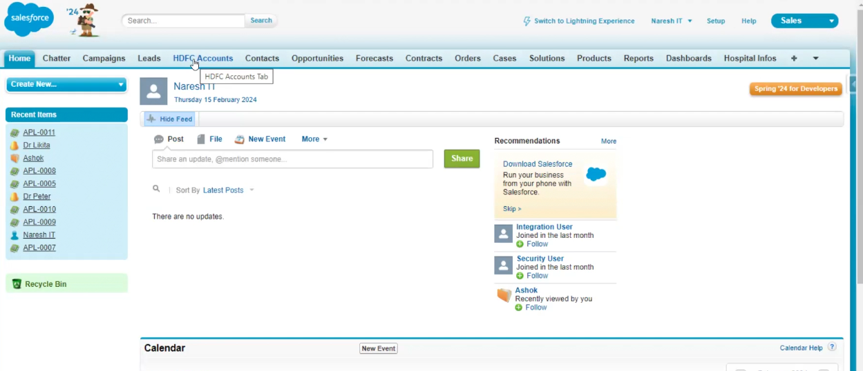

Now the tab is relabeled to account to hdfc Account, my requirement is where account is there must be hdfc account in entire object

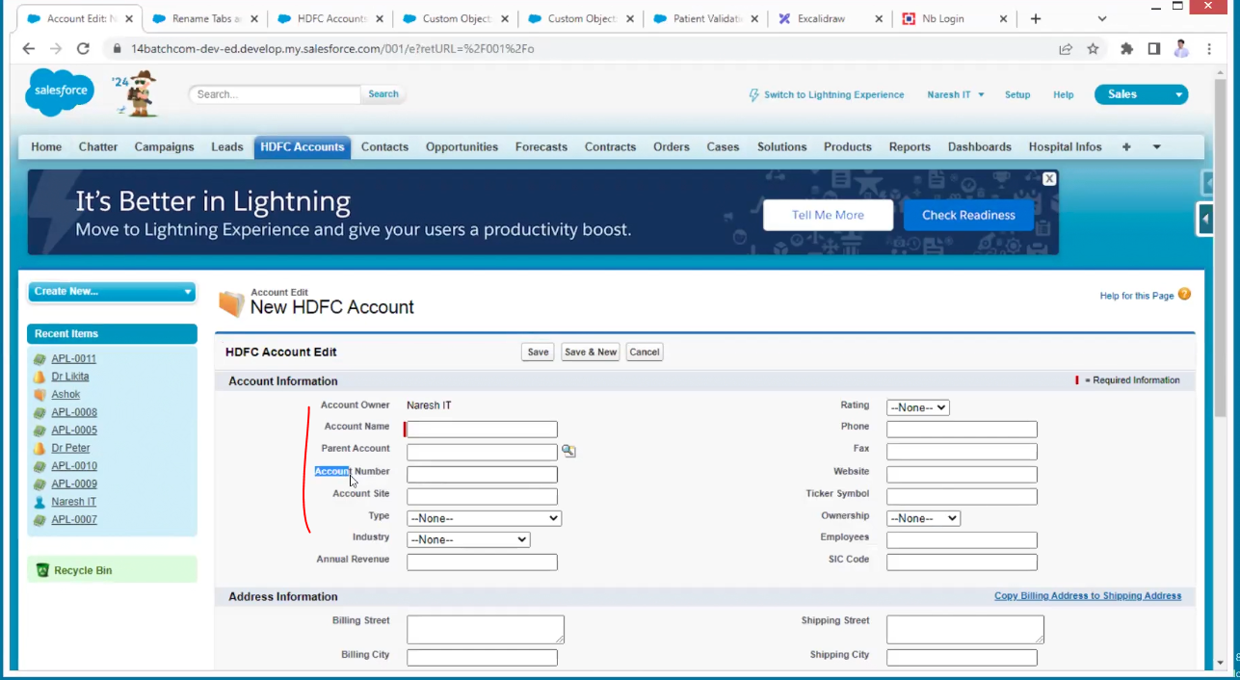

Api names are standard

We are changing only label names

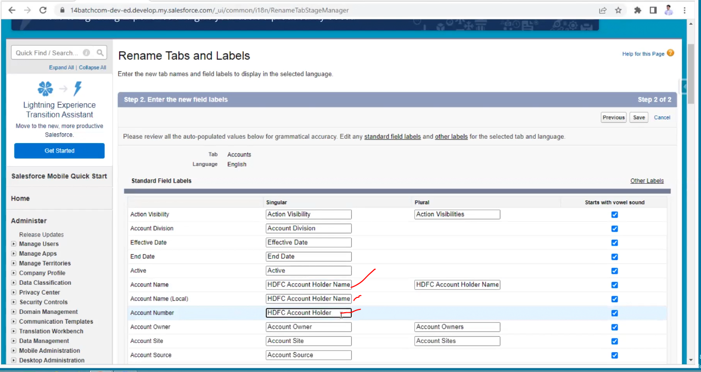

You can edit it here directly

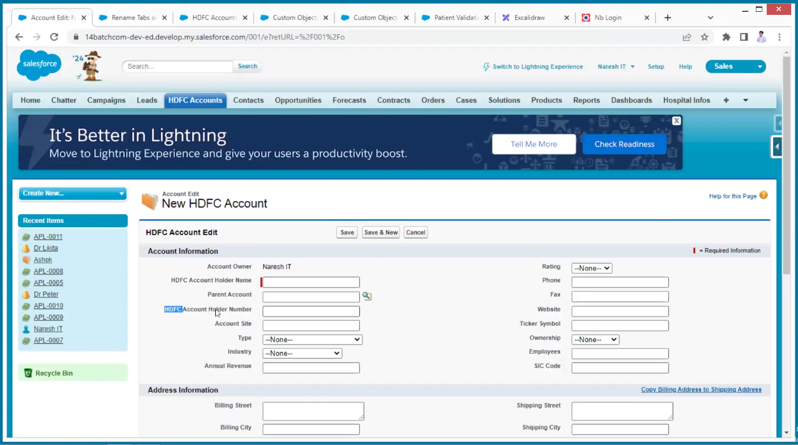

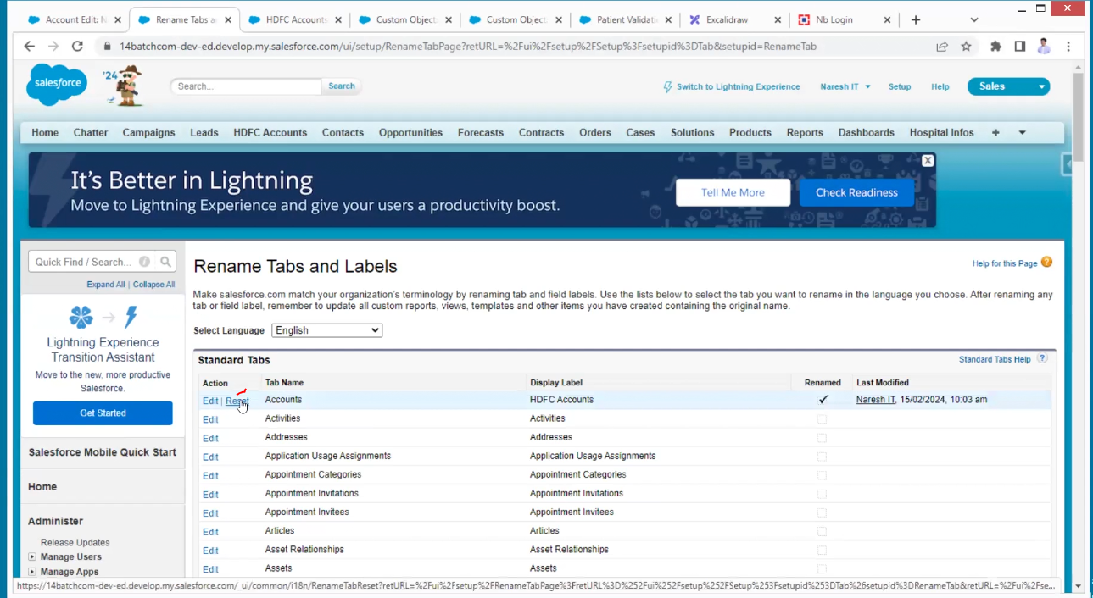

Reset to previous format

Now we are learning about sales applications

It is a default application provided by the salesforce

The sales start from advertisement

1.paper

2.tv

3.social media

4.Events

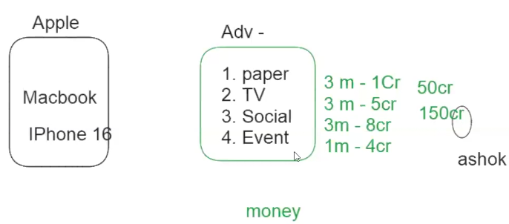

By advertising we are getting sales

So, we can store all this data in one place in the salesforce called campaigns

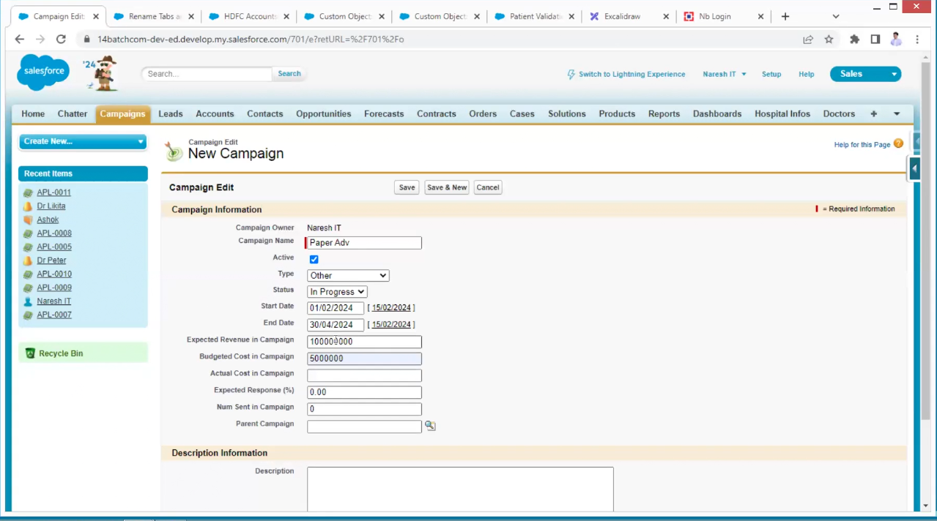

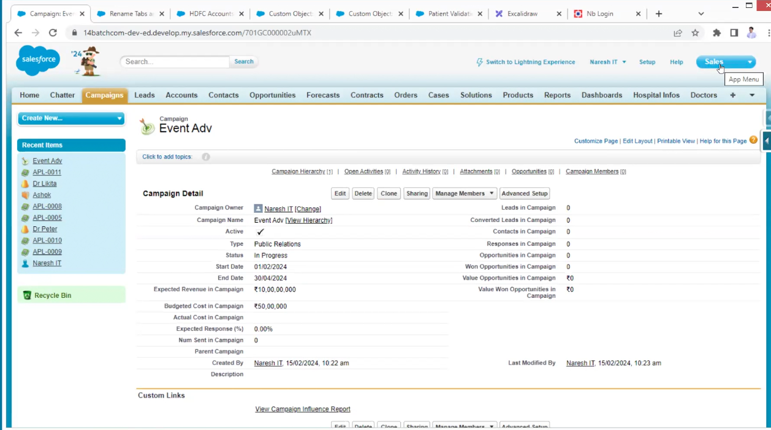

Lead is nothing but who is showing some interest in product

The leads people’s information is storing in the leads in salesforce

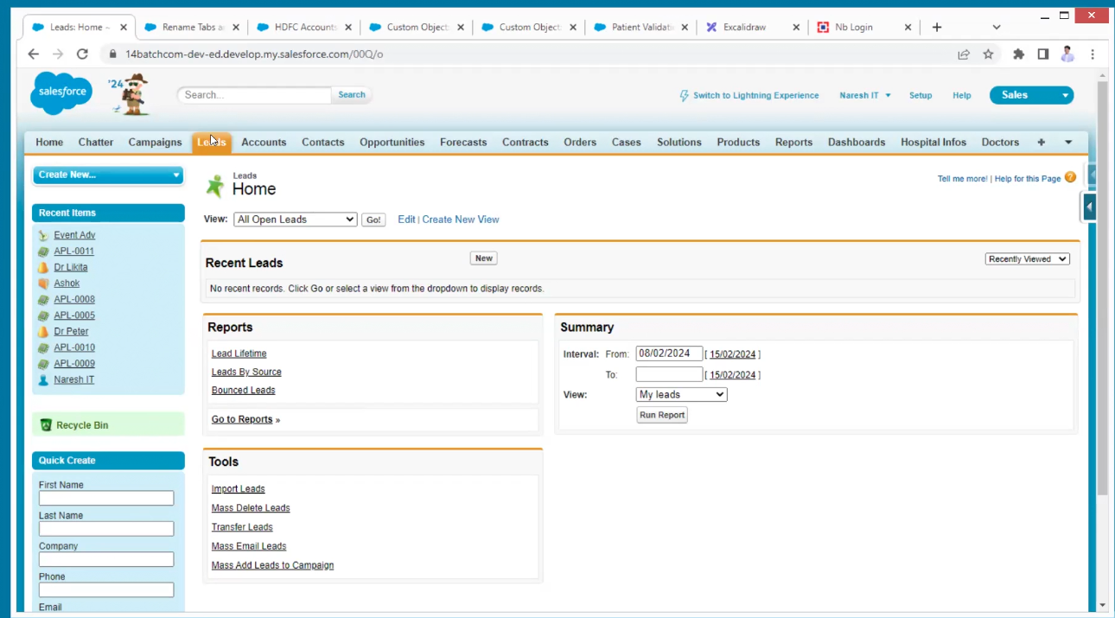

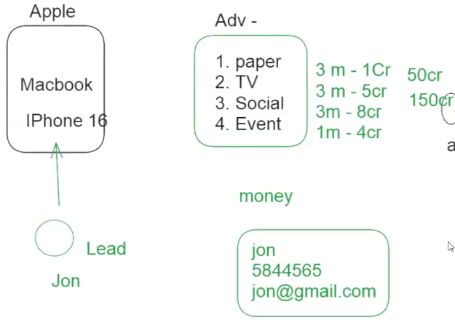

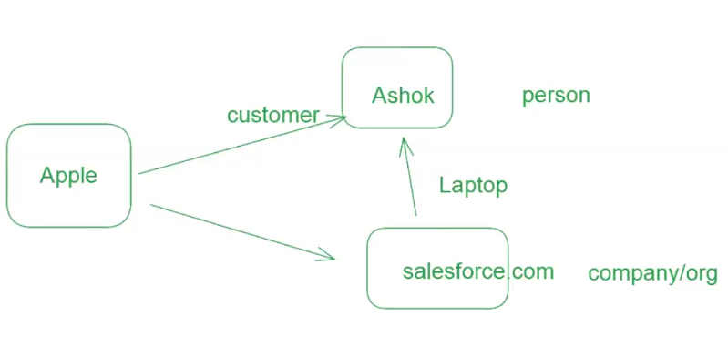

In the above case Ashok is direct lead/customer to apple

In second case he is the indirect customer to apple

In second case company/org is a lead/customer to apple

So, leads will store the information of customers and company/organizations

